Automated Testing Script Development
Framework: Playwright + Pytest (Python)
Application: https://sweetshop.netlify.app/
Prepared by: Netshisumbewa Khangwelo
Date: November 11, 2026

1. Framework Selection

- Chosen Framework: Playwright + Pytest (Python)
- Why Playwright?
- Modern, fast, cross-browser (Chromium, Firefox, WebKit)
- Excellent auto-waiting and resilient selectors
- Built-in video, screenshot, and trace recording
- Native Python support via `pytest-playwright`

3. Key Files

requirements.txt

```txt
pytest==8.3.3
pytest-playwright==0.5.2
playwright==1.48.0
```

pytest.ini
```ini
[pytest]
addopts = -v --headed --slowmo=500 --browser=chromium
testpaths = tests
```

onftest.py

```python
import pytest
from playwright.sync_api import Page

@pytest.fixture(scope="session")
def browser_context_args(browser_context_args):
return {
**browser_context_args,
"viewport": {"width": 1280, "height": 720},
"ignore_https_errors": True,
}

@pytest.fixture
def page(page: Page):
page.goto("https://sweetshop.netlify.app/")
return page
```

tests/test_homepage.py

```python
import pytest
from playwright.sync_api import expect

def test_tc001_homepage_title(page):
"""TC001 - Verify homepage title and heading"""
expect(page).to_have_title("Sweet Shop")
expect(page.locator("h1")).to_be_visible()
expect(page.locator("h1")).to_have_text("Sweet Shop")

def test_tc003_browse_sweets_button(page):
"""TC003 - Verify "Browse Sweets" button"""
button = page.locator('text="Browse Sweets"')
expect(button).to_be_visible()
button.click()
# Adjust selector if the button scrolls or navigates
expect(page.locator("#products")).to_be_visible()
```
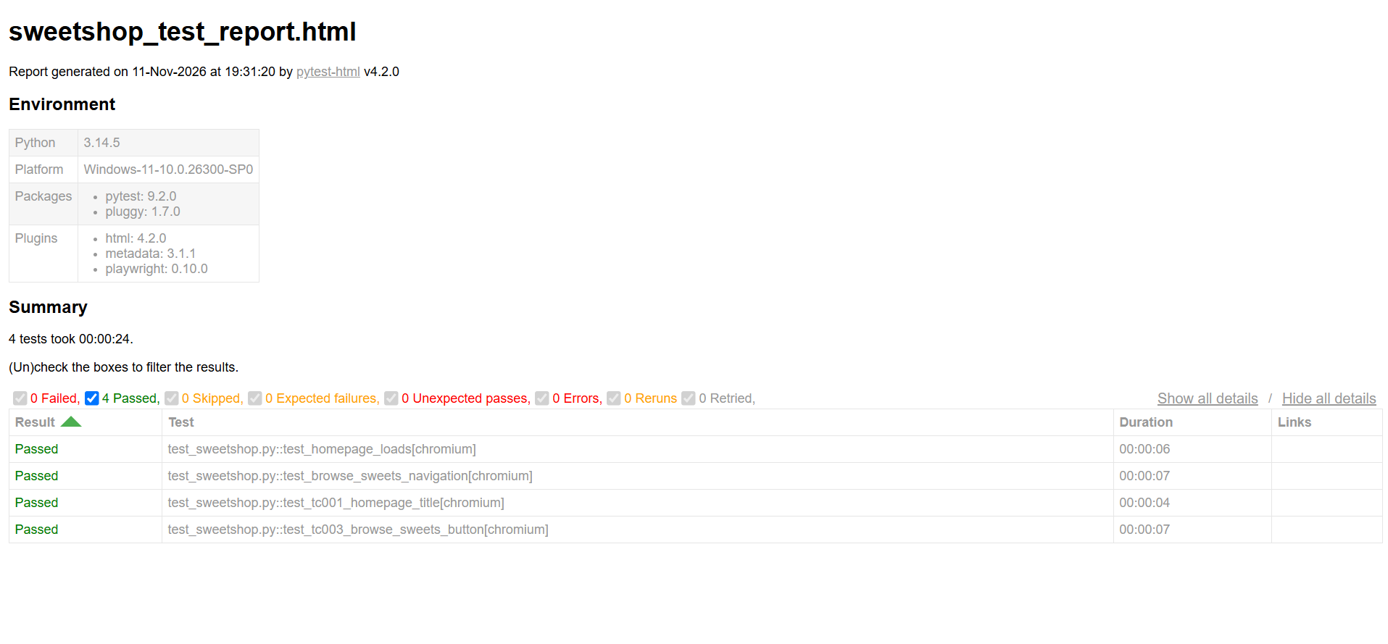

tests/test_products.py

```python
def test_tc006_all_four_sweets_displayed(page):
"""TC006 - Verify all 4 sweets are displayed"""
cards = page.locator(".product-card")
expect(cards).to_have_count(4)

def test_tc007_chocolate_cups_details(page):
"""TC007 - Verify Chocolate Cups details"""
card = page.locator(".product-card", has_text="Chocolate Cups")
expect(card).to_contain_text("£1.00")
expect(card.locator("button")).to_contain_text("Add to Basket")

def test_tc011_product_images_load(page):
"""TC011 - Verify product images load correctly"""
images = page.locator("img")
count = images.count()
for i in range(count):
img = images.nth(i)
expect(img).to_be_visible()
# Check natural width > 0 (image loaded)
expect(img).to_have_js_property("naturalWidth", 0, greater_than=True)
```
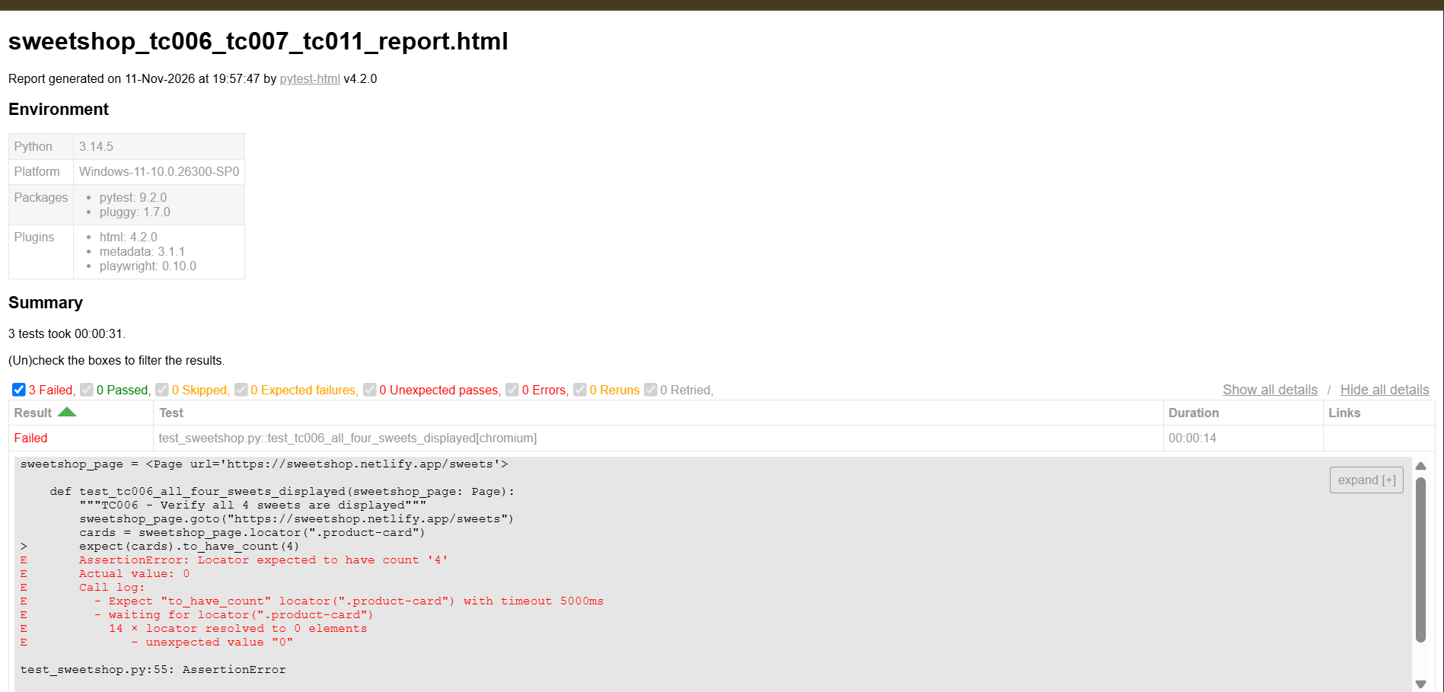
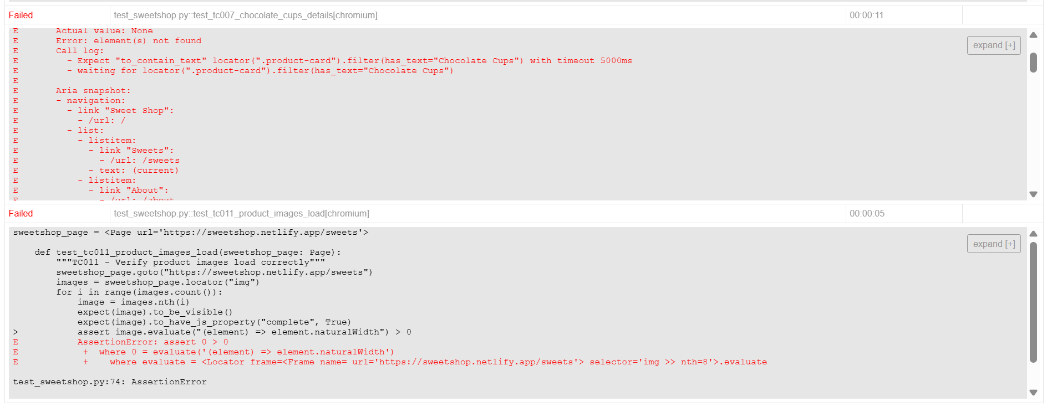

tests/test_basket.py

```python
def test_tc014_add_one_item(page):
"""TC014 - Add one item to basket"""
page.locator("button", has_text="Add to Basket").first.click()
# Adjust selector based on actual basket count element
expect(page.locator(".basket-count")).to_contain_text("1")

def test_tc016_add_all_four_sweets(page):
"""TC016 - Add all 4 different sweets"""
buttons = page.locator("button", has_text="Add to Basket")
for i in range(buttons.count()):
buttons.nth(i).click()
expect(page.locator(".basket-count")).to_contain_text("4")
```
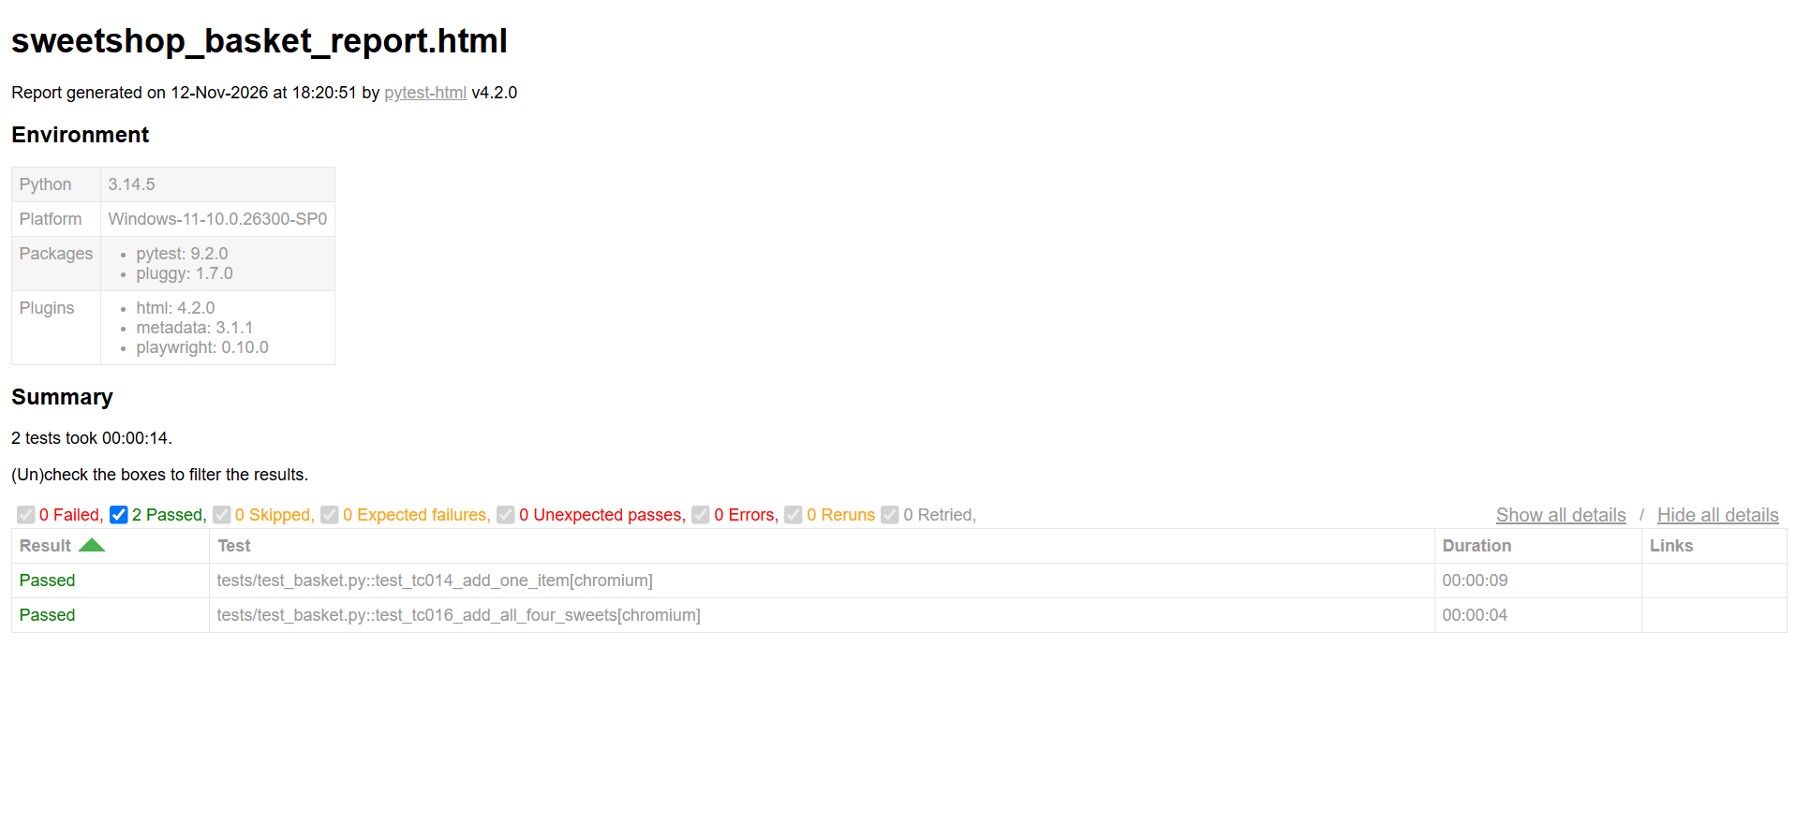

ests/test_responsive.py

```python
def test_tc026_mobile_view(page):
"""TC026 - Verify site on mobile (375px)"""
page.set_viewport_size({"width": 375, "height": 667})
page.reload()
expect(page.locator(".product-card").first).to_be_visible()
# No horizontal scroll
expect(page.locator("body")).not_to_have_css("overflow-x", "scroll")
```
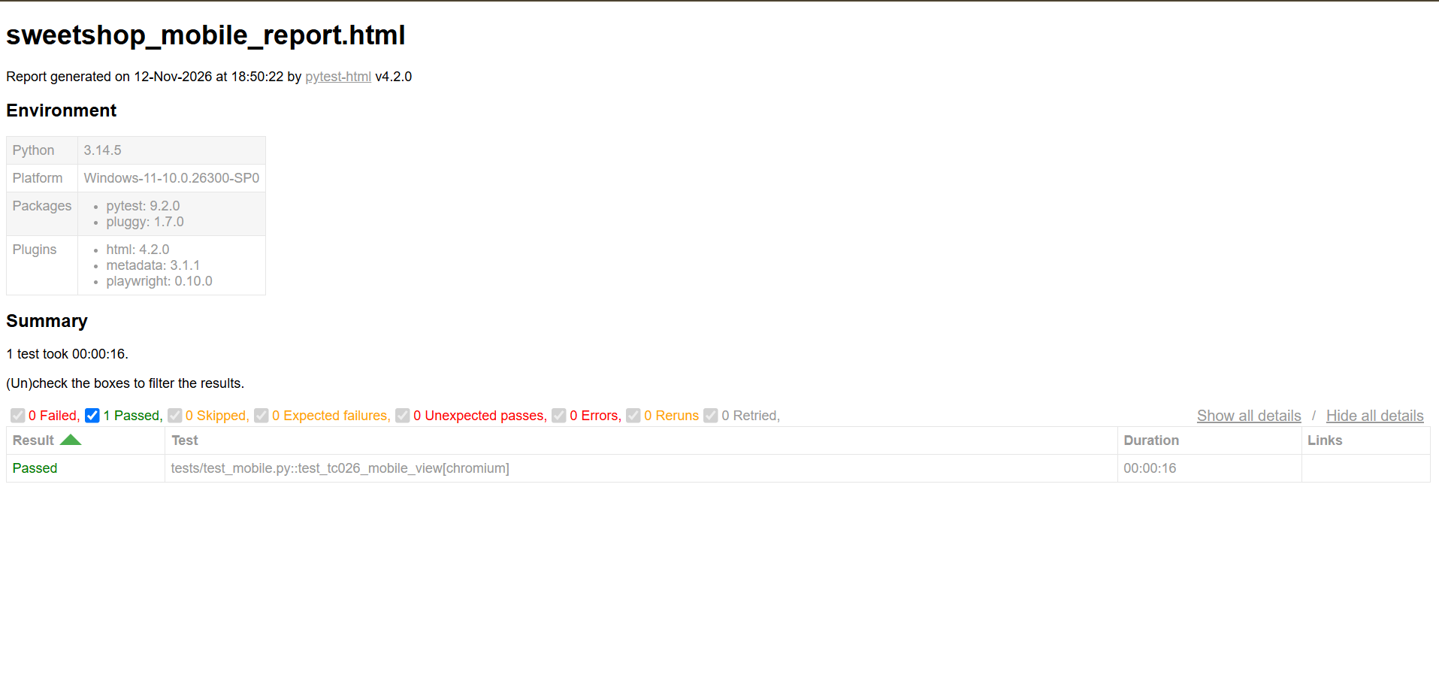
tests/test_accessibility.py

```python
def test_tc033_image_alt_text(page):
"""TC033 - Verify alt text on product images"""
images = page.locator("img")
count = images.count()
for i in range(count):
expect(images.nth(i)).to_have_attribute("alt", r".+")


